Airbus turns to item
Gearing up for lift-off – stairway/platform system developed for Jupiter probe

It’s a spectacular mission! The JUICE (Jupiter Icy Moons Explorer) space probe will spend close to four years studying the Jovian system, including three of its icy moons, to establish whether potentially habitable environments exist. Airbus has spent the past few years developing and building this European Space Agency (ESA) probe, which is currently being prepared for launch. Prior to this, however, the space probe underwent numerous tests at the Airbus satellite integration centres in Friedrichshafen and Toulouse. For this purpose, item designed a special stairway/platform system that provided a safe working platform for staff and served as a substructure for a measuring arm around 10 m long. Some of the project’s many requirements were very much out of the ordinary.

Is there life on Jupiter? Are there extra-terrestrial beings on this planet’s three largest icy moons? Numerous studies are required before we can say for certain. That’s why the European Space Agency (ESA) commissioned Airbus to develop a space probe equipped with measuring instruments and sensors for an in-depth exploration of the Jovian system. Airbus isn’t just one of the world’s leading manufacturers of commercial aircraft. Airbus Defence and Space is a top European manufacturer of aerospace technology. Besides Earth observation and telecommunication satellites, it also develops, builds and tests probes for deep space exploration. BepiColombo (mission to explore Mercury) and the Rosetta comet probe with its lander Philae are just two examples. As ESA’s main contractor for JUICE, Airbus heads a consortium of over 60 companies from all over Europe. More than 150 employees at several of the aerospace specialist’s sites designed and built the space probe to explore the icy moons Ganymede, Europa and Callisto.

Special structure for a sensitive measuring arm
JUICE’s primary objective is to investigate the oceans below the icy surface of Jupiter’s moons using magnetic sensor systems. The magnetic fields will provide information about the internal structure of these celestial bodies. That makes the magnetometer boom (MAGBOOM) a key component of the space probe. Five magnetically sensitive measuring instruments are attached to this measuring arm, which has a total weight of around 50 kg, is made from non-magnetic materials and can be deployed to a length of up to 10.6 m. This ensures the measurements taken are not influenced by the space probe. Before the 6.2-metric-ton probe can embark on its voyage to Jupiter next year, though, it must undergo practical testing. In August 2021, prior to its mission in outer space, JUICE was therefore transported to the Airbus satellite integration centre in Toulouse for final assembly and tests on the satellite and the elaborately designed MAGBOOM. For this purpose, Airbus required a structure that would enable engineers and technicians to carry out installation work and testing on the extremely sensitive measuring arm. The deployable boom is designed to be as lightweight as possible and is dimensioned for an environment that is not influenced by Earth’s gravity. A special substructure was required to support it so that it could nevertheless be deployed on Earth for test purposes without any damage or buckling. This is where item came in. The pioneer in building kit systems for industrial applications worked closely with Airbus to design a special stairway/platform system. Thanks to the optimum support provided by this design, the measuring arm could be partially deployed despite its impressive length. “Having already worked with item before to create smaller test set-ups, we were familiar with its modular building kit systems made up of aluminium profiles and accessories,” says Simon Tröndle, a systems engineer at Airbus. “The profiles are ideal for our project, because they are made of aluminium and are therefore magnetically compatible with the space probe. As a result, there is little if any magnetic interaction,” he adds.

Over 4000 individual components for a special working platform
item supplied Airbus with a total of six modules, creating a platform that is around 5700 mm wide and 5330 mm long, has guard-rails at a height of 1300 mm and is accessible via a stairway. “Our overall system weighs approximately 2.8 metric tons and comprises over 4000 individual components. Completing it involved meeting all kinds of requirements, some of them very specific,” reveals Christian Kirchdorffer, who is responsible for customer solutions at item. The main purpose of the structure as a whole was to simulate gravity-free conditions as similar as possible to the ones in space so the MAGBOOM could be deployed. The stairway/platform system was to provide an optimum substructure and perfect support for the MAGBOOM. A work area also needed to be created for staff to carry out tests on the measuring arm without transferring vibrations or oscillations to the test object or the satellite. Mechanically speaking, the area for staff to stand on therefore had to be completely separate from the MAGBOOM’s substructure. All components needed to have a stainless, cleanroom-compatible design. It was also extremely important for them to exhibit only minimal self-magnetism, because the structure could not be allowed to falsify the measuring results of the sensitive instruments. “Numerous fasteners had to be specially made from stainless steel, so we swapped components such as T-slot nuts, feet, angle brackets and screws made from conventional steel with stainless steel equivalents,” explains Joachim Pfeff, who is responsible for designing customer solutions at item. There were also numerous static requirements to be met. The platform was designed for a load of 200 kg/m² and the Deployment Table at the very top – referred to as the Rollerskate – for a static load of 100 kg. Given that it was to be lifted onto the central platform and aligned there using a crane, this Rollerskate also needed to withstand additional transport-related stresses. The elastic deformation of the surface was not to exceed 1 mm, and analytical proof was provided of this requirement being met. All the usual cleanroom requirements applying to satellite production were also to be complied with. Full ESD protection was another must.

No transfer of vibrations between modules
The big challenge was designing a platform that transfers no vibrations whatsoever to the measuring arm or measuring instruments. Several platforms were therefore built as separate modules that are only connected via a bridge so as to prevent vibration transmission. The Rollerskate rests on the central platform level at several points. Forces are dissipated into the ground. The six modules – left-hand, central and right-hand platforms, bridge, stairway and Rollerskate – can be transported separately. The individual platforms are moved into the correct position with the help of the Swivel Castors fitted to the frame. Height-adjustable anti-slip feet provide the necessary stability and enable initial adjustment. There are three ways of adjusting the central segment’s height. The Adjustable Feet at the very bottom are used for a first rough adjustment. Another platform, also with Adjustable Feet, is located on this central segment. Further Adjustable Feet, this time on the Rollerskate, provide a third possibility for adjusting the height. This arrangement ensures the height of the levels can be aligned very precisely. What’s more, the well thought-out system means the deployment level can be adjusted to within 0.05°, which was a key requirement for the MAGBOOM deployment process.

Compliance with highest safety standards and cleanroom requirements
“The item design provided an ideal working environment for our staff,” explains Tröndle. “For example, it was very easy for them to modify measuring heads and carry out the necessary tests. They also had perfect access to all areas,” he adds. Airbus put its trust in the experience and expertise of item, including in terms of occupational health and safety. The pioneer in building kit systems for industrial applications designed the stairway/platform system in accordance with the applicable occupational health and safety regulations and standards, together with further requirements of the accident insurance and prevention institutions. All safety aspects were factored in so as to make a point of avoiding accidents and falls and thus create a safe working environment. In addition, item conducted a full structural analysis and determined the deflection of the individual components. The construction and assembly of the individual modules were comprehensively documented. Furthermore, it was initially unclear whether the modules would be transported by crane or forklift, so item needed to take appropriate measures. Installation in a cleanroom environment was a further requirement. When profiles are cut to size, oil is often used to cool the components. Residues and lubricant can remain on the inside of the profiles, thereby contaminating the environment. The isopropanol item uses for cooling when cutting profiles to size is volatilised without leaving any residues. The resulting profiles are very clean and thus meet cleanroom requirements. “We were able to inspect and approve the entire solution on site at item. Only then were the individual modules painstakingly packed in specially made crates and transported to France,” reports Tröndle. “Besides the design, item therefore also took care of the logistics, providing us with excellent support throughout the entire project. We were, at all times, in close touch with a single contact, who adapted very well to our specific aerospace mindset in a partnership of equals. Despite the numerous – and in some cases complex – requirements, I rate the collaboration as highly productive and solution-oriented,” he concludes.

Length: 10,668 characters including spaces
Date: 09 November 2023

Photos: 5

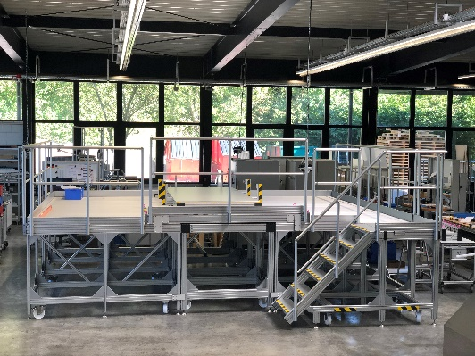
Caption 1: In close collaboration with Airbus, item designed a special stairway/platform system for the JUICE space probe to provide perfect support for the MAGBOOM measuring arm, together with a working level that ruled out any transfer of vibrations. Source: item

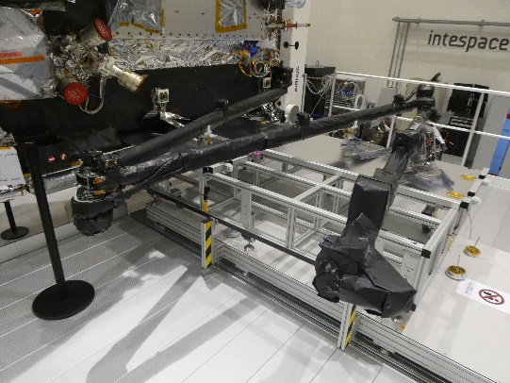
Caption 2: The MAGBOOM, which is over 10 m long, can be deployed safely thanks to the substructure. This means final tests can be carried out before the probe is launched into space. Source: Airbus

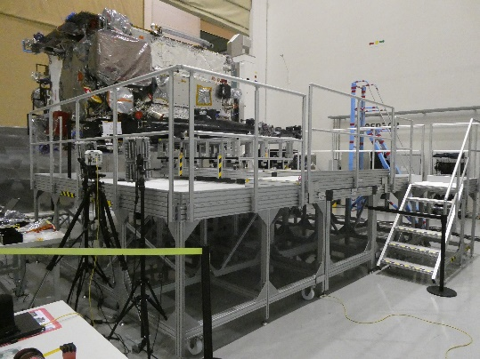
Caption 3: The platform must not transfer any vibrations whatsoever to the measuring arm or measuring instruments, so six separate modules were built. These were transported to the Airbus Astrolabe in Toulouse and assembled on site. Source: Airbus

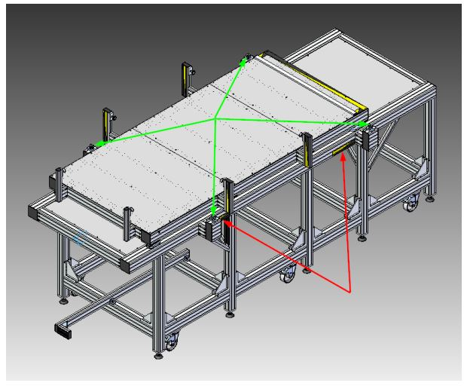
Caption 4: Since it was initially unclear whether the modules would be transported to their final destination by forklift or crane, item fitted appropriate points of support and lifting points. Source: item

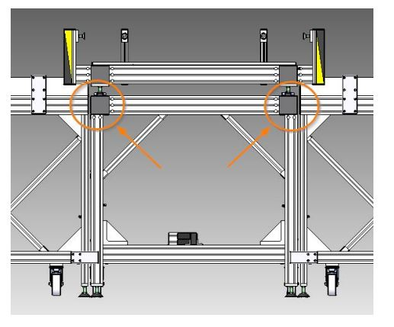
Caption 5: There are three sets of Adjustable Feet to adjust the central segment’s height, which ensures the levels can be aligned with millimetre accuracy. Source: item

About item
item Industrietechnik GmbH is the pioneer in building kit systems for industrial applications and a partner of the manufacturing industry across the entire globe. Today, the item product portfolio comprises more than 4000 high-quality components designed for use in machine bases, work benches, automation solutions and lean production applications. The company has received a string of awards for products with ground-breaking industrial design and end-to-end ergonomics.

item is spearheading digital engineering by driving forward the digitalisation of processes with software tools developed in-house. The item Academy offers training at various levels, with on-demand training and online courses available in multiple languages.

Headquartered in Solingen, Germany, item has subsidiaries in various countries. Some 900 employees worldwide harness their know-how and passion to develop innovative solutions and services. Eleven sites make sure the company is always close to customers in Germany, with a global logistics chain ensuring swift delivery times for all components.

Company contact
Nicole Regelin • item Industrietechnik GmbH
Friedenstraße 107–109 • 42699 Solingen
Tel.: +49 212 65 80 5188 • Fax: +49 212 65 80 5427
E-Mail K.Regelin@item24.com • Internet: www.item24.com

Press contact
Jan Leins • additiv pr GmbH & Co. KG
Press work for logistics, steel, industrial goods and IT
Herzog-Adolf-Strasse 3 • 56410 Montabaur • Germany
Tel.: +49 26 02-95 09 91 6 • Fax: +49 26 02-95 09 91 7
Email: jl@additiv-pr.de • Internet: www.additiv-pr.de/maschinenbau

