Easy installation and ergonomic control of lightweight robots
A highly cohesive cobot table design –
creating ideal working conditions

Sleek, elegant and stylish – when designing its new cobot tables, GRIP GmbH Handhabungstechnik placed the main emphasis on aesthetics. Nonetheless, functional and ergonomic aspects also played an important role in creating a perfect working environment to operate lightweight robots. The specialist in robot peripherals therefore used item aluminium profiles as a basis for its table frame with partitioned storage options. Combining secure protection with quick and easy access, the drawers and compartments are ideal for accommodating the control cabinet, the control unit and additional tools.

GRIP GmbH Handhabungstechnik was established in 1989 and currently employs 40 staff at its site in Dortmund. The company specialises in components for robot peripherals and generates an annual turnover of just under five million euros. Besides developing products such as special grippers and quick-change systems for robots, it is also involved in the project engineering and production of bespoke turnkey fixtures and specialist mechanical engineering solutions that are tailored to customer requirements. GRIP is already a certified UR+ product partner, meaning it supplies components that can be easily and conveniently combined with the lightweight robots of the Danish manufacturer Universal Robots.

Profile technology as a basis for a highly functional cobot table
Ever since GRIP became an item pluspartner in 2013, it has been contributing its special expertise in robot and handling technology to this network. “We use item profile technology for all our testing and assembly equipment,” says GRIP Managing Director Hasan Canti. “The Building Kit System is very versatile, so we also utilise it for specialised fixtures, enclosures, racks, guard-rails and work benches. Our new cobot table is based on item system components, too,” he adds. Designed specifically for the use of cobots – lightweight robots that help people with their work – the table needed to be aesthetically appealing and multifunctional. It is made from Line XMS aluminium profiles. To make the table easier to transport, its footprint of 1200 x 800 mm was deliberately matched to the size of a europallet. The cobot can be fixed onto the table’s Groove Plate quickly and easily thanks to various Adapter Plates and the GRIP Base Connector. This quick-change system makes the task of connecting together the robot arm and table very straightforward, meaning the robot can be fixed in place with absolute precision in one simple action. A special device made from aluminium profiles can be attached alongside the cobot. This can be used, for example, to hold multiple GRIP grippers. Thanks to the GRIP Auto Connector, it is therefore possible for the robot to switch quickly between various grippers for different applications. The resulting work bench perfectly integrates the GRIP components and can also be ideally adapted to the relevant requirements thanks to its modular structure.

Clever details and an attractive design
“We wanted to integrate all the robot technology and peripherals into the table without compromising the overall look. Working closely with customer advisor Giuliano Longo and other employees from item, we developed an aesthetically pleasing and high-quality solution,” continues Canti. For example, the control cabinet is not fitted in the usual way, but in a drawer, meaning it can’t be seen from the outside. The drawer can be pulled out as required, and the lid of the control cabinet can be opened from above. That makes working on terminals inside the control cabinet much more ergonomic and convenient. Instead of being attached to the outside of the structure, the manual control unit for programming the cobot is also stowed in a drawer when not in use, keeping it well protected. A separate outlet allows for optimum cable routing. Another drawer provides space for tools, assembly sets and other components. The lower section of the table can be used to store additional technology and electronics – for the WLAN connection, for example. The table is also open at the bottom, allowing for ideal heat transfer, while lockable doors protect vital equipment from unauthorised access. “Besides the functional aspects, it was the design of the cobot table that particularly impressed me – stylish with a clean, linear look, similar to a laboratory bench,” emphasises Canti.

Flexibly adaptable at any time
The cobot table is equipped with Jacking Castors, meaning it can be fixed firmly in place on stable feet or pushed to different installation locations on the castors. In addition to the electrical connection, it also has an air supply connection for the pneumatic operation of the grippers and other end effectors. The standard version of the table already offers a great many functions, but it can also be modified and enhanced as required, because the modular item Building Kit System offers numerous configuration options. For example, the control unit can optionally be installed in a fixed location on the table. This flexible configuration also extends to add-ons, which can be adapted perfectly to the task in hand. Components such as enclosures, extra drawers, safety technology and lighting fixtures can be added to the cobot table at any time. The table’s footprint can also be expanded to suit the customer’s specific requirements. GRIP is hoping the cobot table will obtain UR+ certification so it can supply a further peripheral product for the collaborative robots manufactured by Universal Robots. “The design of the table is timeless, the quality of the item components is second to none, and the product versatility is outstanding,” underlines Canti. “item is constantly developing new components and boasts exceptional delivery reliability. Regardless of whether I order ten or 1000 components, they arrive within 48 hours,” he reveals, adding that ordering via the Online Shop is easy and convenient. What GRIP appreciates most, though, is the technical support item offers, together with the expert assistance and high degree of professionalism it receives throughout the planning and implementation stages of its projects thanks to being a member of the item pluspartner network.

Harnessing numerous benefits as an item pluspartner
“When item told us about the pluspartner concept, we were immediately sold, and we’re now delighted to belong to this network of industrial technology experts and specialists,” says Canti. He adds that the basic concept of bringing together a variety of companies from similar specialist fields has led to numerous successful projects, that sharing ideas in a partnership of equals is highly advantageous, and that businesses can provide each other with optimum support when developing new products and dealing with complex tasks. Challenging projects can thus be successfully implemented by working with partners from different branches of industry.

Length: 7514 characters including spaces
Date: 25 January 2023

Photos: 5

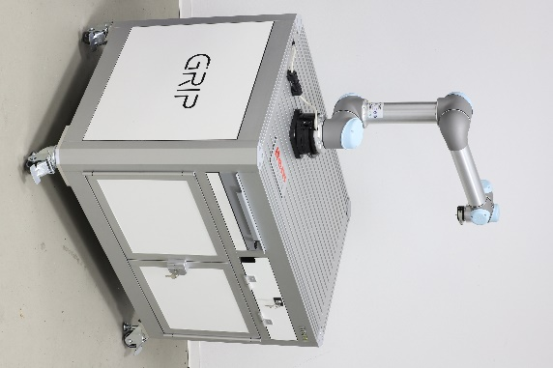
Caption 1: Made using system components from item, the new GRIP cobot table isn’t just highly functional, but also aesthetically appealing. Source: item

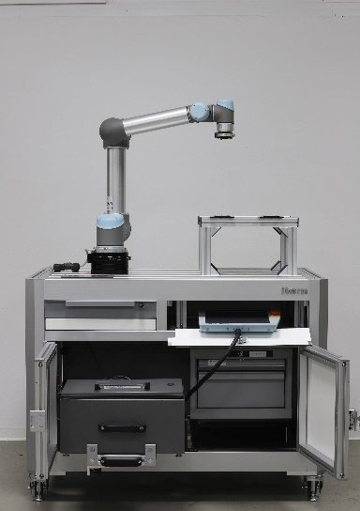
Caption 2: The control cabinet is accommodated in a drawer, making it more convenient to operate. Similarly, instead of being attached to the outside of the structure, the manual control unit for programming the cobot is stowed in one of the table’s compartments. Source: item

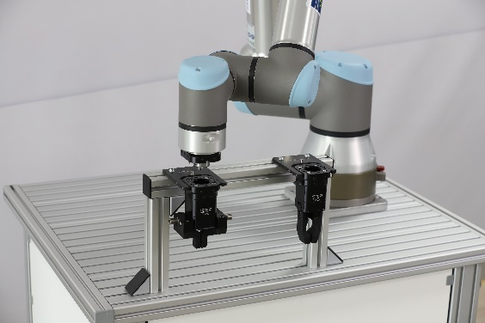
Caption 3: The cobot can be fixed onto the table’s Groove Plate quickly and easily. A special device made from aluminium profiles can be used, for example, to hold GRIP grippers. Source: GRIP

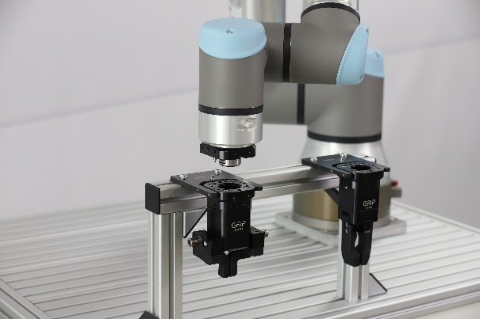
Caption 4: The standard version of the table already offers a great many functions, but it can also be modified and enhanced as required. For example, add-ons can be flexibly configured and perfectly adapted to the task in hand. Source: GRIP
Caption 5: A wide range of possible uses at a glance. Source: item

About item
item Industrietechnik GmbH is the pioneer in building kit systems for industrial applications and a partner of the manufacturing industry across the entire globe. Today, the item product portfolio comprises more than 4000 high-quality components designed for use in machine bases, work benches, automation solutions and lean production applications. The company has received a string of awards for products with ground-breaking industrial design and end-to-end ergonomics.

item is spearheading digital engineering by driving forward the digitalisation of processes with software tools developed in-house. The item Academy offers training at various levels, with on-demand training and online courses available in multiple languages.

Headquartered in Solingen, Germany, item has subsidiaries in various countries. Some 900 employees worldwide harness their know-how and passion to develop innovative solutions and services. Eleven sites make sure the company is always close to customers in Germany, with a global logistics chain ensuring swift delivery times for all components.

Company contact
Nicole Hezinger • item Industrietechnik GmbH
Friedenstrasse 107 - 109 • 42699 Solingen • Germany
Tel.: +49 212 65 80 5188 • Fax: +49 212 65 80 310
Email: n.hezinger@item24.com • Internet: www.item24.com

Press contact
Jan Leins • additiv pr GmbH & Co. KG
Press work for logistics, steel, industrial goods and IT
Herzog-Adolf-Strasse 3 • 56410 Montabaur • Germany
Tel.: +49 26 02-95 09 91 6 • Fax: +49 26 02-95 09 91 7
Email: jl@additiv-pr.de • Internet: www.additiv-pr.de/maschinenbau

