Maximum flexibility in production
Liebherr opts for the building kit system from item
Working ergonomically and efficiently – the employees at Liebherr are the beating heart of the entire production process. This is also true in Colmar (France), where Liebherr-Components develops and manufactures large diesel engines. To provide staff with the best possible support in their work and enable lean production, the company uses components from item throughout its plant.

The Liebherr Group is a technology company with around 48,000 employees. Its product range covers 13 segments – from refrigerators and fridge-freezers to construction machinery, cranes and diggers for a range of applications. Ever since its foundation in the town of Kirchdorf an der Iller in southern Germany in 1949, it has pursued the goal of impressing customers with high-quality solutions and playing a part in technological progress. Liebherr-International AG, based in Bulle (Switzerland), is the central holding company of the Group. At its site in Colmar, France, Liebherr produces hydraulic diggers and other components for the mining sector. In 2014, a new production facility focusing on the development, design, assembly and inspection of large diesel engines was constructed next to the buildings of Liebherr-Mining Equipment SAS. The new D98 diesel engine series from Liebherr-Components Colmar SAS is suitable for use in mining applications, but also in oil and gas extraction and railway engineering.

Flexible, modular components for production environments
To equip the new production facility, Liebherr in Colmar was looking for a company that can deliver flexible and adaptable products. “Lean principles are firmly anchored in our Group,” says Stefan Schmid, who is responsible for production and the planning, implementation and optimisation of the production facilities at Liebherr-Components in Colmar. “We place great importance on lean, efficient production. The modular system from item, with its intelligent functionality and compatible products, immediately made a great impression on us.” The numerous components from the pioneer in building kit systems for industrial applications can all be freely combined with each other. This made it possible to create individually height-adjustable work benches for the production staff. Some of the item Work Bench System components are fitted with castors, meaning the benches can be moved around. The team leader’s height-adjustable work bench is also made up of components from the item Work Bench System. Both its look and its functionality fit in well with the production environment. Liebherr uses item SystemMobiles for material supply, order picking and transporting boxes and tools for preliminary assembly. The diesel engine specialist also uses customisable enclosures and guard systems to protect its employees. In addition, safety equipment and frames for switchboxes were constructed from item aluminium profiles and matching accessories. In keeping with the Japanese lean concept of 5S, the company created a clean, safe and organised working environment. For example, aluminium profiles, fasteners and hinges were used to create clever concepts for storing and rapidly removing tools, screwing technology and cleaning materials. Even cleaning utensils can be attached to trolleys or in cupboards using appropriate fixings. “We use both purely item constructions and hybrid systems in our production,” says Schmid. “In some of our transport trolleys, we use prefabricated support structures combined with a superstructure made of item components to transport turbochargers for example.”

Integrating ergonomics into production sequences
item systems can be perfectly integrated into the entire production process, during which large diesel engines weighing 9 to almost 16 metric tons are created. The constructions provide sufficient stability for processing prepackaged components and assembling them on the respective work benches. “We integrate the systems harmoniously into the production process so that they can be put to perfect use for the individual production steps,” Schmid explains. “For example, work benches made from item components are suitable for inspections, preassembly and cleaning work.” Liebherr uses products such as Pivot Arms, Trays with Stop Profile and Grab Containers to create a working environment with an optimum ergonomic design. Employees can set up the keyboard and screen to suit their needs and position them in such a way as to provide perfect support for their natural movement sequences and efficiently avoid strenuous movements. Liebherr continuously conducts investigations at the workplace to examine the adaptability and ergonomic orientation of the products. The company relies on adaptable workstations that staff can move to the positions they want.

Customised work benches boost productivity
The constructions from the aluminium profiles with appropriate fasteners and other accessories make it possible to create customised work benches. These are adapted to the needs of the workforce and ensure an ergonomic working environment. “Our work benches need to be safe, clean and organised,” says Schmid. “Employees find the tools exactly where they need them – ready to use and close to the process. Every part has a set place that can be reached easily and ergonomically.” Right from the outset, planning focused on fundamental lean principles. Using 5S and other lean methods, Liebherr is creating efficient and reliable processes. Employees are always at the heart of things. The company aims to continuously improve how things are done. To this end, employees focus intensively on the individual processes so as to spot any problems at an early stage, identify potential and opportunities for improving processes, and implement changes. As part of this, the number of tools was also reduced to a minimum. The level of organisation and order at the work bench is increased as a result. In line with the lean philosophy, every little change has effects on the entire process. As a consequence, throughput times can be optimised and productivity increased.

3D printing for special requirements
Stefan Schmid and his team design special holders and other aids for fastening measuring devices and filling containers themselves, then produce these using a 3D printer. The holders they manufacture in this way are then fitted to the work benches directly via the item Groove 8. As a result, employees have the measuring tools directly within reach and ready to use at their work bench instead of having to remove them from their packaging for each measuring process. “We cover our most specific needs using our 3D printer if item doesn’t have anything suitable in its portfolio,” says Schmid. “At the same time, of course, we have to keep costs and workload within reason.”

Maximum flexibility is valuable for the future, too
Since the start of production, the Liebherr-Components production line has been expanded several times to integrate new process steps. This was particularly challenging, as it involved both the planning and the implementation of production equipment and engine constructions at the same time. The ongoing development of the engine also took place in parallel to production, and this had to be taken into account, too. Production therefore continued to grow gradually. For each workstation, more worksteps were added to those carried out at the outset. If rigid, standard systems had been used, they would soon have reached their limits and it wouldn’t have been possible to adapt the working environment so easily. This is why the diesel engine manufacturer values the product diversity, modularity and constant addition of new, useful components to the modular system they find with item. “We have to stay flexible going forward – for example to make further optimisations in terms of efficiency and cycle times or to quickly implement new products,” Schmid adds. “Systems that can be modified make us future-oriented and enable us to face new challenges with determination.”

Connected by partnership
Liebherr uses item products across the board. This can also be seen in its requirements for suppliers of turning systems and screw technology. These requirements specify that item components must be used. The engine manufacturer prefers perfect integration without interfaces so as to benefit from the advantages a uniform system offers in terms of flexibility and maintenance. Liebherr also appreciates the option of using item courses to train its employees in how to use the products. “Throughout the entire project phase, we received comprehensive support – for example to enable us to use the item configurators,” says Schmid. “item is very interactive and engaged, and our collaboration is very much like a partnership – and it has been for almost ten years now.”

Length: 9,493 characters including spaces
Date: 21 March 2023

Photos: 7 (Source: Liebherr)

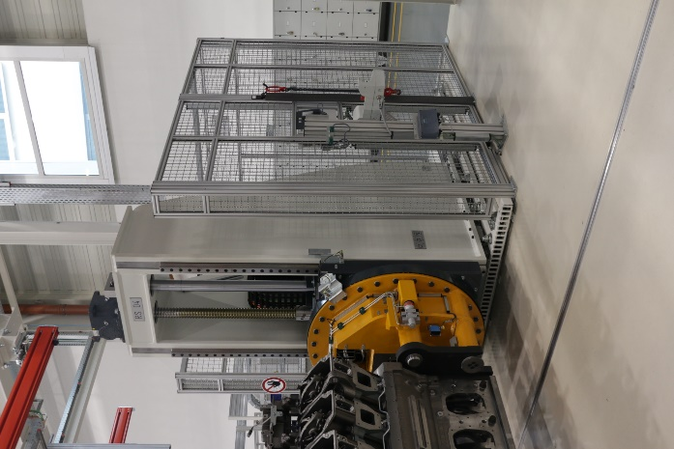
Caption 1: In its production line for manufacturing large diesel engines, Liebherr-Components uses enclosures and guards based on aluminium profiles and other components from item.

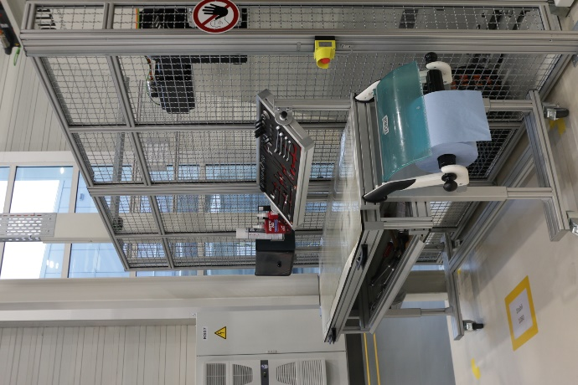
Caption 2: The work benches in assembly are ergonomic and height-adjustable. They can be moved to other positions as required.

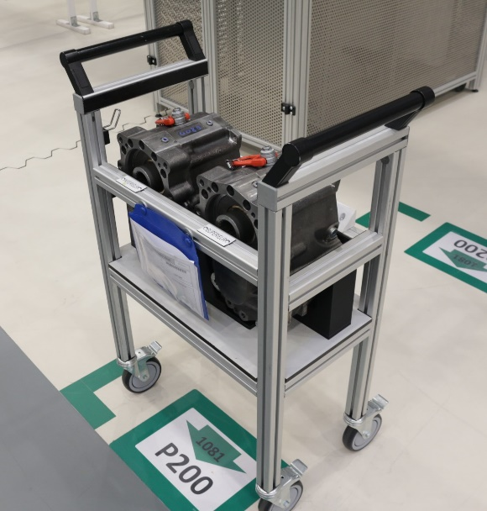
Caption 3: item SystemMobiles are stable and transport heavy loads with maximum safety.

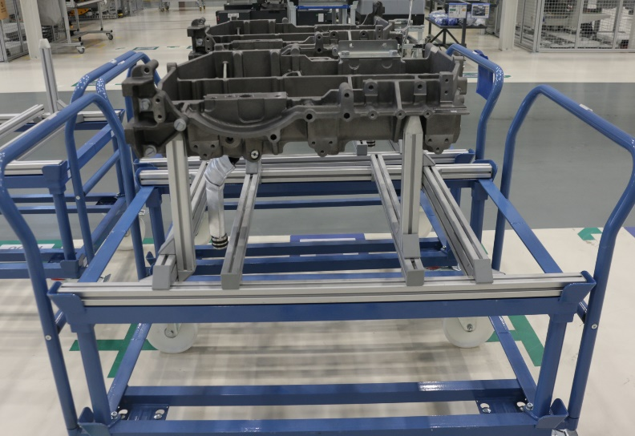
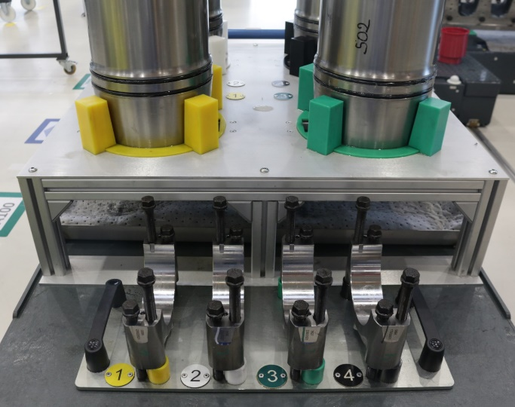

Images 4 and 5: Liebherr in Colmar also uses hybrid systems with special substructures and superstructures made from aluminium profiles.

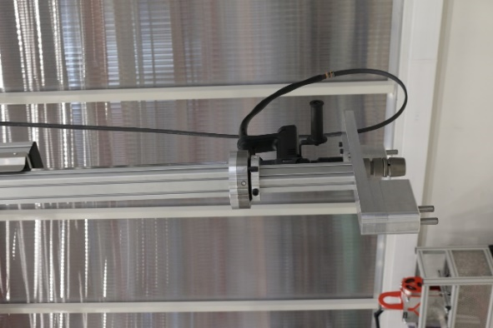
Image 6: item components are used throughout the production facility, such as here as a screw application on a telescope for torque support.

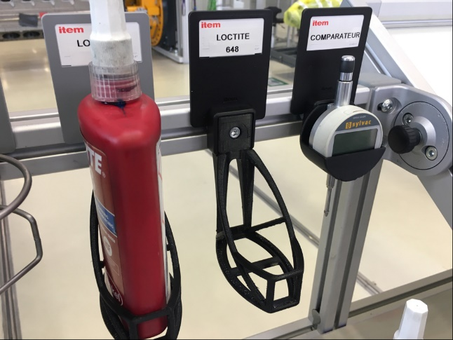
Image 7: Employees at Liebherr use a 3D printer to produce specialist holders for measuring devices or filling containers that can then be fitted directly to the work benches via the item Groove 8.

About item
item Industrietechnik GmbH is the pioneer in building kit systems for industrial applications and a partner of the manufacturing industry across the entire globe. Today, the item product portfolio comprises more than 4,000 high-quality components designed for use in machine bases, work benches, automation solutions and lean production applications. The company has received a string of awards for products with ground-breaking industrial design and end-to-end ergonomics.

item is spearheading digital engineering by driving forward the digitalisation of processes with software tools developed in-house. The item Academy offers training at various levels with on-demand training and online courses available in multiple languages.

Headquartered in Solingen, Germany, item has subsidiaries in various countries. Some 900 employees worldwide harness their know-how and passion to develop innovative solutions and services. Eleven sites make sure the company is always close to customers in Germany, with a global logistics chain ensuring swift delivery times for all components.

About Liebherr-Components AG
The Liebherr Group specialises in developing, designing, producing and refurbishing high-performance components in the field of mechanical, hydraulic and electrical drive and control technology in this segment. Liebherr-Component Technologies AG, based in Bulle (Switzerland), is responsible for coordinating all activities in the components product segment.
Its comprehensive portfolio includes diesel and gas engines, injection systems, engine control units, axial piston pumps and motors, hydraulic cylinders, large roller bearings, gearboxes and cable winches, switchgear, electronic and high-performance electronic components, and software. Its high-quality components are used in cranes and earth-moving equipment, in the mining industry, in maritime applications, in wind farms, in vehicle technology, in aviation and in traffic technology. Synergy effects with the other product segments of the Liebherr Group are used to continuously drive forward technological development.

About the Liebherr Group
The Liebherr Group is a family-led technology company with a broadly diversified product range. The company is one of the largest construction machinery manufacturers in the world, but also supplies high-quality, practical products and services in many other areas, too. The Group currently includes more than 140 companies on every inhabited continent, has a workforce of approximately 48,000 employees, and achieved consolidated total sales of more than 10.3 billion euros in 2020. Ever since its foundation in the town of Kirchdorf an der Iller in southern Germany in 1949, it has pursued the goal of impressing customers with high-quality solutions and playing a part in technological progress.

Company contact
Nicole Hezinger • item Industrietechnik GmbH
Friedenstrasse 107 - 109 • 42699 Solingen • Germany
Tel.: +49 212 65 80 5188 • Fax: +49 212 65 80 310
Email: n.hezinger@item24.com • Internet: www.item24.com

Press contact
Jan Leins • additiv pr GmbH & Co. KG
Press work for logistics, steel, industrial goods and IT
Herzog-Adolf-Strasse 3 • 56410 Montabaur • Germany
Tel.: (+49) 26 02-95 09 91 6 • Fax: (+49) 26 02-95 09 91 7
Email: jl@additiv-pr.de • Internet: www.additiv-pr.de/maschinenbau

