Highly adjustable machine cabins
The perfect working environment for robots and more
Networking, researching, training – Mehnert Lab in Erfurt is a hub for industrial collaboration in the age of Industry 4.0. The Mehnert Lab factory has a variety of machines and systems that are used to develop future-focused projects for many different companies and test new technologies directly on site. Mehnert was looking for aesthetically pleasing, functional and at the same time flexible equipment with which to fit out its cutting-edge research facility. item Industrietechnik offered just the right solution by engineering eight machine cabins from aluminium profiles, which can be adjusted to specific requirements.

Mehnert GmbH provides skilled workers and specialists for various projects in the fields of electrics, mechanics, digital control, 3D measurement technology and robotics. It has 55 permanent employees, is headquartered in the Zwickau district of Mülsen and has a subsidiary in Erfurt. The team is active all over the world and focuses on building, maintaining and servicing state-of-the-art industrial plants. A few years ago, Managing Director René Mehnert founded Mehnert Lab in Erfurt, which facilitates a new form of industrial collaboration and creates the perfect working environment for training top-class specialists. In addition to cutting-edge seminar rooms and areas for events and workshops, the lab also has a 600 m² space for machine and system technologies, which houses a variety of robot systems and controls commonly used in mechanical engineering.

Finding the right components and modules
In summer 2019, René Mehnert was looking for suitable partners to fit out the lab. The aim was to create the perfect basis for test structures. This would involve creating machine cells that can be operated independently or interconnected to simulate a complete production line. The project was overseen by an Erfurt-based engineering firm. “I was looking for a local supplier who could deliver aesthetically pleasing components that were both stable and flexible at the same time,” explains Mehnert. “item was an immediate contender. In addition to the elegant design and functionality of the components, I was won over by the quality, straightforward compatibility, and sheer size of the portfolio.”

Customisable machine cabins
Thanks to its location in Mühlhausen, item is only a few kilometres away from Erfurt and thus just a short distance from Mehnert Lab. Once the project was underway, the initial designs for the lab equipment were drawn up in collaboration with the engineering firm. Cabins measuring 1.60 metres wide and over 2 metres tall were constructed for the 600 m² space and prepared for use with robots. This involved item supplying numerous components from its MB Building Kit System, such as Groove Plates, Robot Mounting Plates, aluminium profiles and the corresponding fasteners, along with hinges and other accessories. “The item components lay the foundation for seamlessly integrating additional systems,” says Steve Syhre, project manager at item. “We created several profile-based structures, fastening options for robots, and the entire frame for the laboratory cells.” The switchboxes with the corresponding electronics are located in the lower section of the machine cabins. The switchbox systems with doors and hatches were also built using item components. The workspaces, which can be viewed from all sides, are located above and consist of a stable Groove Plate and a frame made of 80×80 mm aluminium profiles. These spaces are also equipped with transparent elements to ensure the interior is protected and the cells can only be accessed through doors on one side. The supply lines run through the pillars. The systems are operated from the outside using corresponding controllers.

A winning flexible, modular design
While item worked with the engineering firm to take care of the planning, Mehnert employees cut the components to size and assembled the cells. They delved deep into the portfolio offered by the pioneer in building kit systems for industrial applications, for instance by making full use of the item online configurators for numerous tasks. “Our cells provide a framework, but we can also expand and resize them if necessary,” explains Mehnert. “Customers therefore benefit from a perfect environment in which projects can be conducted easily and conveniently.” Each of the eight cells can be operated independently, but they can also form a complete production line, as Mehnert can arrange the individual cells side by side. The systems are not rigid, meaning they can be adapted to suit specific needs. Mehnert is able to do this with the help of the huge item portfolio, which includes over 4,000 components and is constantly being expanded with further innovations. This ensures customers can design the machine cabin that best suits their requirements. “The clear advantage of the components is just how quickly they can be assembled and disassembled,” says Mehnert. “Constructions made from welded profiles do not offer this level of flexibility.” Another advantage item offers is that even older profiles can be easily combined with the current ones. “This means, for example, that you don’t need to change product ranges every five years,” the managing director points out. For him, aesthetics also play a major role: “Thanks to the smooth surface and elegant design of the aluminium profiles, our constructions will still look completely cohesive 30 years from now.”

A win-win situation
item maintained close contact with Mehnert throughout the entire project. “We really appreciate the partnership and intense support we got from item,” emphasises Mehnert. “item was always there to offer us advice and support. This meant we were able to find a solution even in difficult situations.” Not all the cells have been completed yet. On top of that, thoughts have already turned to the next step in this collaboration, for instance introducing additional components for lean production or work bench systems. “We see the Mehnert Lab as a permanent exhibition where companies can showcase their products and innovations,” says Mehnert. “It is much like a trade fair that runs for 365 days a year.” The robot cells are rented out for a certain period of time, meaning employees from many different companies can be trained. However, start-ups and universities are also welcome to use the available peripherals for their own projects. Ultimately, this means a range of companies and institutions will come into contact with item components – a win-win situation for everyone involved.

Whether it’s new business models, innovative service concepts or practical, application-oriented solutions – the Mehnert Lab makes room for creative ideas. In doing so, it makes the opportunities of digitalisation and global competition a tangible reality. “Our goal is to see several companies work with different technologies in the lab and also benefit from each other in a way that advances their respective projects,” says Mehnert. “The item components enable us to provide the perfect platform for this, while our lab opens up opportunities to share information in a dynamic setting, not to mention ideal sales opportunities.”

Length: 7,725 characters including spaces
Date: 22 July 2021

Photos: 5 (Source: Susann Nuernberger Corporate Photography)
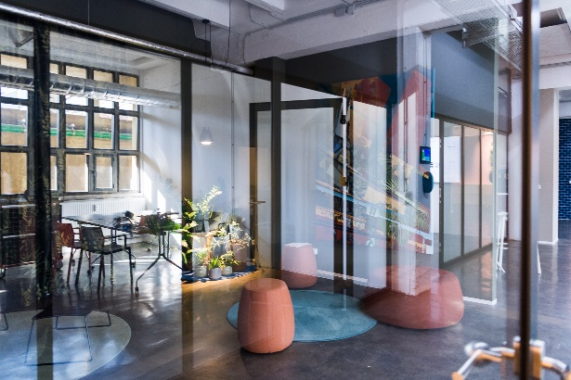
Caption 1: Mehnert Lab makes room for creative ideas. It offers ideal conditions for companies to train employees and drive forward future-focused projects.

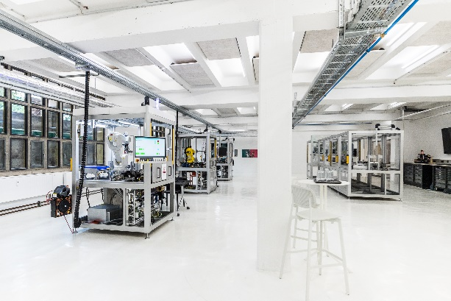
Caption 2: The machine cabins made from item aluminium profiles can be operated independently or connected side by side to simulate a complete production line.

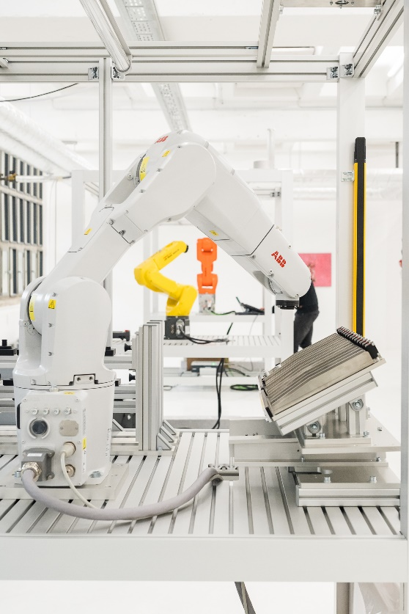
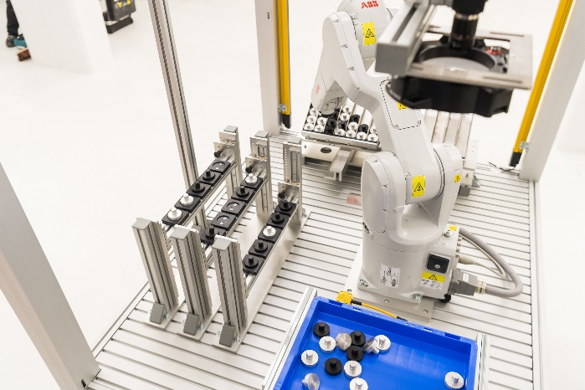

Captions 3 and 4: Groove Plates, Robot Mounting Plates and other accessories from item make it possible to attach robots inside the cells and customise the cells with essential components.

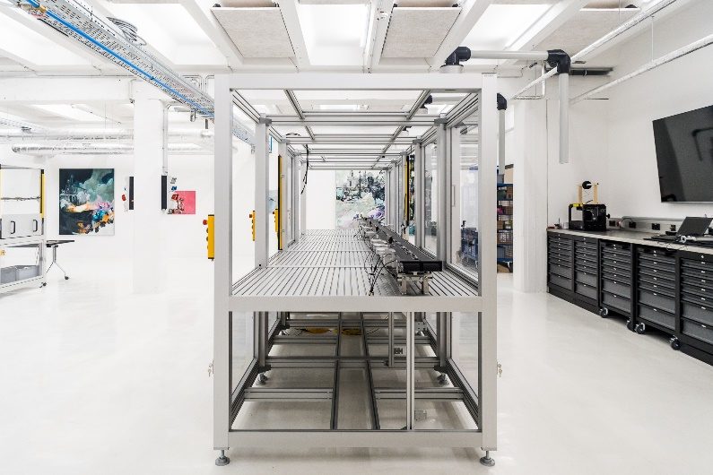
Caption 5: The cells made from item aluminium profiles provide the framework, but can also be expanded and resized if necessary. Users benefit from an ideal environment where their projects can be conducted easily and conveniently.

About item
item Industrietechnik GmbH is the pioneer in building kit systems for industrial applications and a partner of the manufacturing industry across the entire globe. Today, the item product portfolio comprises more than 4,000 high-quality components designed for use in machine bases, work benches, automation solutions and lean production applications. The company has received a string of awards for products with ground-breaking industrial design and end-to-end ergonomics.

item is spearheading digital engineering by driving forward the digitalisation of processes with software tools developed in-house. The item Academy offers training at various levels with on-demand training and online courses available in multiple languages.

Headquartered in Solingen, Germany, item has subsidiaries in various countries. Some 900 employees worldwide harness their know-how and passion to develop innovative solutions and services. Eleven sites make sure the company is always close to customers in Germany, with a global logistics chain ensuring swift delivery times for all components.

Company contact
Nicole Hezinger • item Industrietechnik GmbH
Friedenstrasse 107 - 109 • 42699 Solingen • Germany
Tel.: +49 212 65 80 5188 • Fax: +49 212 65 80 310
Email: n.hezinger@item24.com • Internet: www.item24.com

Press contact
Jan Leins • additiv pr GmbH & Co. KG
Press work for logistics, steel, industrial goods and IT
Herzog-Adolf-Strasse 3 • 56410 Montabaur • Germany
Tel.: (+49) 26 02-95 09 91 6 • Fax: (+49) 26 02-95 09 91 7
Email: jl@additiv-pr.de • Internet: www.additiv-pr.de/maschinenbau

