Keeping valuables safe with the Valiomat system
How linear technology is automating access to safe deposit boxes

The Valiomat automated safe deposit box system is available 24/7, offering customers easy access to their valuables at any time of the day or night. When MS Protect AG was developing the system a number of years ago, it opted to put its trust in linear technology from item. As a result, the safe deposit boxes are transported from the vault to the output station securely, quickly and reliably.

Linear technology is used whenever anything needs to move along an axis. When the robust linear units from item are used for this purpose, even complex applications can be implemented with ease – including a high-bay storage system inside a vault. In 2009, Swiss company MS Protect launched its Valiomat system onto the market, thereby offering customers access to their safe deposit boxes 24/7. These customers are given a chip card to gain access to a separate room where the output station is located. The Valiomat solution uses a track-guided carrier system – the carriage – to transport the safe deposit box from a type of high-bay storage system to the output station. This process takes place with the help of a timing-belt or rack drive from the item Linear Technology Building Kit System. The first step involves the safe deposit box being retrieved from the relevant compartment and transported along horizontal and vertical axes. At the output station, two-factor customer authentication is required. Only when this step has been successfully completed will the output station locker open, thus enabling the customer to add or remove their valuables. The carriage then transports the box back to its place in the secure vault.

Flexible design thanks to the item Building Kit System
MS Protect has so far installed almost a hundred of these systems in total. The modular structure means different designs are possible – the Valiomat system can be adapted to suit the relevant building layout perfectly, whether it is all on ground level or comprises several levels and whether there are multiple output stations or just one. There are virtually no limits when it comes to the design. In recent years, for example, systems up to 24 metres long and ten metres high have been built. The item Linear Unit KLE 6 60x60 LR with a timing-belt drive is used for system lengths of up to 12 metres, whereas the Linear Unit LRE 8 D14 80x40 ZS with a rack drive is used when longer distances are involved. Both drives offer outstanding long-term reliability and ensure high speeds can be achieved. “The system has been operating without a hitch for years,” says Simon Schefer, Managing Director of MS Protect AG. “So far, we haven’t had to replace a single linear unit, which means we can offer a high level of availability.” The overall system is very compact, but can also be flexibly expanded as needed. The individual safe deposit boxes come in various sizes and the partitions can be altered, even after completion. This means they can be adapted in line with current requirements at any time – without any need for complex reconstruction work.

For a video and more information about the functions and application potential of the Valiomat system, take a look at the interactive e-paper from item, which is available at
https://welcome.item24.de/ineartechnik-im-einsatz-epaper-msprotect-de

Length: 3,213 characters including spaces
Date: 05 April 2023

Photos: 3 (Source: 3D-Cube.ch agency, Patrick Manser)

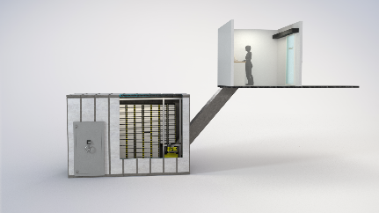
Caption 1: The Valiomat automatic safe deposit box system consists of the output station and a vault with a type of high-bay storage system containing the safe deposit boxes.

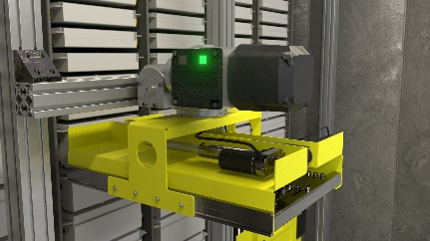
Caption 2: A track-guided carrier system transports the safe deposit box to the output station, along vertical and horizontal axes. This process takes place with the help of a timing-belt or rack drive from the item Linear Technology Building Kit System.
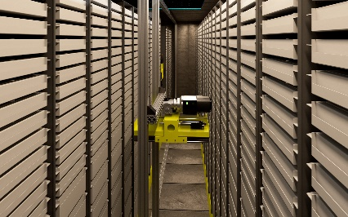
Caption 3: The overall system is very compact, but can also be flexibly expanded as needed. What’s more, the safe deposit box partitions can be altered in line with current needs, even after completion.

About item
item Industrietechnik GmbH is the pioneer in building kit systems for industrial applications and a partner of the manufacturing industry across the entire globe. Today, the item product portfolio comprises more than 4500 high-quality components designed for use in machine bases, work benches, automation solutions and lean production applications. The company has received a string of awards for products with ground-breaking industrial design and end-to-end ergonomics.

item is spearheading digital engineering by driving forward the digitalisation of processes with software tools developed in-house. The item Academy offers training at various levels, with on-demand training and online courses available in multiple languages.

Headquartered in Solingen, Germany, item has subsidiaries in various countries. Some 900 employees worldwide harness their know-how and passion to develop innovative solutions and services. Twelve sites make sure the company is always close to customers in Germany, with a global logistics chain ensuring swift delivery times for all components.

Company contact
Nicole Hezinger • item Industrietechnik GmbH
Friedenstrasse 107 - 109 • 42699 Solingen • Germany
Tel.: +49 212 65 80 5188 • Fax: +49 212 65 80 310
Email: n.hezinger@item24.com • Internet: www.item24.com

Press contact
Jan Leins • additiv
A brand of additiv pr GmbH & Co. KG
B2B communications for logistics, robotics, industry and IT
Herzog-Adolf-Strasse 3 • 56410 Montabaur • Germany
Tel.: +49 26 02-95 09 91 6 • Fax: +49 26 02-95 09 91 7
Email: jl@additiv.de • Internet: www.additiv.de

