Turning an idea into reality
When it comes to its customised 3D measurement systems, senswork puts its trust in item

Flexibility and precision for industrial automation – senswork GmbH develops customised solutions for industrial image processing and optical measurement systems. With its state-of-the-art machine cabins and inspection systems, the company offers flexible, cost-effective solutions for challenging production environments. To ensure the very highest quality standards and maximum efficiency, senswork uses tried-and-tested profile technology from item for its innovative 3D measurement system designed for the inline measurement of components.

Founded in 2011, senswork GmbH is a leading supplier of turnkey solutions in the fields of industrial image processing, optical measurement systems and automatic inspections. With sites in Burghausen and Munich in Germany, as well as international branches in the USA, China and Singapore, the company serves well-known customers from a variety of sectors, such as the automotive industry and the medical technology, electronics and food technology sectors. senswork develops customised solutions such as innovative camera systems and inspection equipment for automation and quality assurance applications in state-of-the-art production processes. In its Innovation Lab in Munich, the company works on pioneering artificial intelligence technologies for image processing and analysis. With a workforce of more than 35 employees, senswork offers everything from a single source – from developing the concept all the way through to integrating the finished solution.
Flexibility is all-important
In view of growing demands in industrial production – especially in quality assurance – highly precise, efficient measurement systems are a must. It is vital that they ensure high levels of process reliability – and it must also be possible to flexibly adapt them to suit a variety of customer requirements and production environments. When it comes to complex components such as battery cells, a whole host of conditions – both functional and, most importantly, safety-related – need to be met. Three-dimensional measurement is one method of inspecting battery cells in order to prevent risks such as short-circuits and overheating. This is why senswork developed its ZScan® Easy 3D measurement system, which can complete a full 3D inline measurement of components such as battery cells within a matter of seconds. The senswork team, which initially developed this system as a prototype for the international trade fair Control, built a machine cabin that provides optimum protection against external influences, such as dust or changing light conditions during imaging, and can also be perfectly adapted to suit each customer’s specific needs. Choosing the right components is a crucial step in the design process for such constructions. This is where item comes in – because its flexible profile technology offers significant advantages over rigid welded systems that can only be modified with major effort. Thanks to its modular design, the ZScan® Easy measurement system can be extended and modified to suit specific needs as required. This is especially important, because senswork always needs to supply customised inspection-cell solutions that meet the needs of a variety of sectors – from the automotive industry to electronics production.
A focus on Line XMS profiles
“We’ve been an item customer since 2021 and are using a whole range of constructions,” says Daniel Müller, who is in charge of design engineering at senswork. “For instance, we’ve built lots of machine bases out of their aluminium profiles. We’ve also configured work bench systems, added our inspection technology to them, and then delivered them to our customers,” he explains. When it came to developing the innovative ZScan® Easy inspection system, senswork opted for Line XMS profiles from item to build its machine cabins. These profiles impress with their smooth surfaces and good looks, as well as their integrated cable conduits – another functional benefit, since this feature keeps cabling neat, tidy and clean. “We’ve used products from the extensive item portfolio before, often opting for standard profiles with the appropriate fasteners. When it came to building our new measurement cell, though, our preference was for Line XMS profiles. Thanks to Cover Profiles, it’s really easy to cover the cables that are integrated into the profiles – a very convenient solution that looks good, too,” Müller explains. Operating elements such as pushbuttons, switches and plug sockets can also be inserted directly into the profiles.
Design and function of the measurement cell
The ZScan® Easy 3D measurement system is available in a variety of sizes and designs that are custom-built in line with the customer’s express wishes. The top section of the machine cabin is the process section, which is fitted with transparent panels and contains the surface scanners. Two swing doors made from acrylic glass provide access to this section so that the component to be scanned can be positioned as required. Line XMS Door Profiles are used to create stable, precisely closing doors with a slender aluminium frame. Lip Seals cover the gap between the door and the frame to prevent the accumulation of dust. The bottom section, which is the supply section, also has doors for access purposes. At the side of the machine cabin is a movable Pivot Arm assembly with a monitor that shows the measurement values. Multiple 3D surface scanners scan parts such as battery cells with virtually no shadowing. Products measuring up to 2.0 m in length, 2.0 m in width and 1.5 m in height can be scanned by up to eight scanners, which generate a high-resolution 3D image with up to 12 million measurement points. It takes only a few seconds to scan even large components. The results can be transferred directly to production. Reliable quality assurance therefore takes place directly in the manufacturing line. This is of fundamental importance, especially when it comes to the high-cost production of lithium-ion batteries for electric cars – a sector in which reliable production with the lowest possible reject rate is a key aim.
Engineering with item – smart and cost-effective
The decision to use item components to build the ZScan® Easy inspection system has proved to be an excellent one for a number of reasons. One major benefit is the modularity of the profiles, which enables senswork to design flexible, adaptable measurement systems. Thanks to the ingenious Line XMS profile system, it was possible to route the machinery cables cleanly and efficiently, for example, while smart signalling technology displays the status of the inspection process at all times. LED Strips, which can be integrated into the profile groove, light up either in sections or along their full length. Thanks to the use of different colours, the status of the process is immediately apparent, and the IO-Link Controller from item can be used to achieve custom control. This also provides a simple and convenient way of indicating the progress of the process. Besides the free selection of colours, different flashing patterns can be used, too. “The Ball Joints from item are another really clever solution. We’ve installed them in the top section of the machine cabin so we can attach our scanners to them,” says Müller. Thanks to these Ball Joints, the scanners can be rotated in different directions. A Clamp Lever ensures the angle can be adjusted quickly. The robust aluminium profiles are highly reliable, even when used in challenging industrial environments. However, they are also lightweight, so machines and inspection systems can be transported with ease. And on the subject of transport, another noteworthy feature is the Jacking Castor, which combines a castor with a height-adjustable, non-slip knuckle foot. Thanks to these strong castors, the 3D measurement system can be pushed to wherever it is needed. The integrated knuckle foot is then simply lowered into position. It can compensate for slight differences in height and ensures the measurement system is standing securely.
Constructive collaboration
The collaboration between senswork and item is characterised by a constructive, partnership-based approach that makes it possible to develop customised solutions for challenging industrial applications. “Collaboration with item is really straightforward,” Müller emphasises. “Thanks to short lines of communication and close coordination between our two companies, projects can be carried out promptly and efficiently. The short delivery times for item components really help with this, too,” he continues. In addition, senswork particularly appreciates how easy it is to access detailed product information and engineering data on the item website. This helps senswork make modifications quickly and independently, thereby enabling the company to work out the best solutions for special requirements. “We are particularly impressed by the wide variety of components and accessories. We also use the profiles and fasteners for fixtures and fittings in our Innovation Lab in Munich, for example, or on a general basis for creating prototypes. These don’t take long to build – and they can be altered or extended with similar speed,” Müller adds. All in all, senswork benefits not only from standardised products in the item portfolio, but also from its constant expansion – and this ensures flexibility and adaptability for future projects, too.

As at: 31 October 2024
Length: 9448 characters including spaces
Image data: 5 (© senswork)

Captions
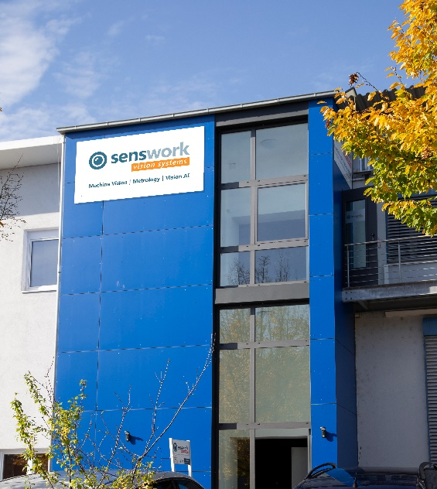
Figure 1 senswork specialises in turnkey solutions for industrial image processing, automatic inspection and deep learning (AI).

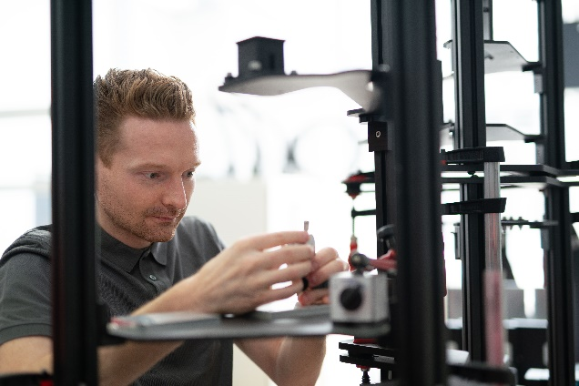
Figure 2 The company develops equipment for measuring and inspecting workpieces.

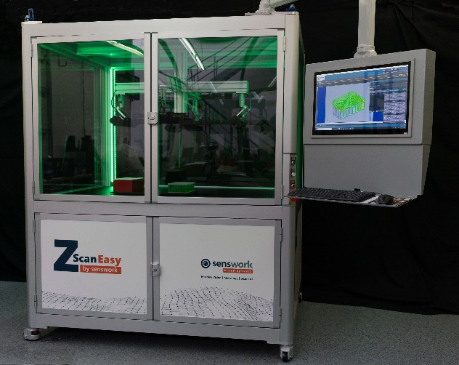
Figure 3 With ZScan® Easy, components such as battery cells can be scanned in 3D with speed and precision. The machine cabin is made from item components.

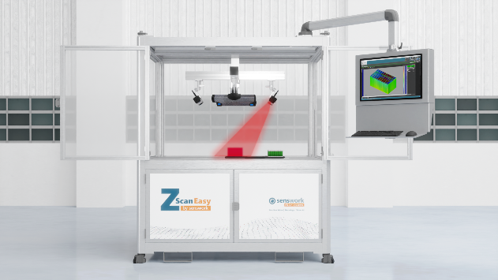
Figure 4 The top section of the measuring system is the process section, while the bottom section is the supply section. Line XMS Door Profiles are used to create stable, precisely closing doors with a slender aluminium frame.

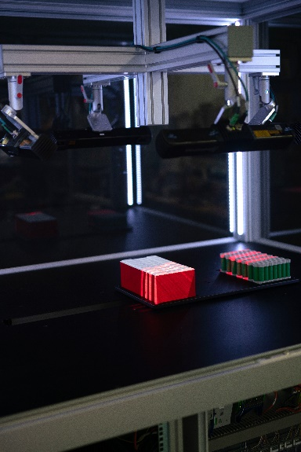
Figure 5 Ball Joints from item are used in the top section of the machine cabin so that the scanners can be rotated in different directions. Smart signalling technology is used to indicate the status of the process.

About item
item Industrietechnik GmbH is the pioneer in building kit systems for industrial applications and a partner of the manufacturing industry across the entire globe. Today, the item product portfolio comprises more than 4500 high-quality components designed for use in machine bases, work benches, automation solutions and lean production applications. The company has received a string of awards for products with ground-breaking industrial design and end-to-end ergonomics.
item is spearheading digital engineering by driving forward the digitalisation of processes with software tools developed in-house. The item Academy offers training at various levels, with on-demand training and online courses available in multiple languages.
Headquartered in Solingen, Germany, item has subsidiaries in various countries. Some 900 employees worldwide harness their know-how and passion to develop innovative solutions and services. Eleven sites make sure the company is always close to customers in Germany, with a global logistics chain ensuring swift delivery times for all components.

Company contact
Katja Regelin • item Industrietechnik GmbH
Friedenstrasse 107 - 109 • 42699 Solingen • Germany
Tel.: +49 212 65 80 5427
Email: k.regelin@item24.com • Internet: www.item24.com

Press contact
Jan Leins • additiv
A brand of additiv pr GmbH & Co. KG
B2B communications for logistics, robotics, industry and IT
Herzog-Adolf-Strasse 3 • 56410 Montabaur • Germany
Tel.: +49 26 02-95 09 91 6 • Fax: +49 26 02-95 09 91 7
Email: jl@additiv.de • Internet: www.additiv.de

