Customised door solutions for wide passageways and flexible applications
New double doors from item create secure access points in any size

item is expanding its portfolio of door solutions with its new double doors. Aluminium profiles up to 6,000 mm long enable large, sealed passageways – for example, for transporting bulky structures or wide goods. Thanks to coordinated components, the two door leaves are easy to construct, can be customised and lock reliably.
Whether in clean rooms, machine cabins or production facilities – large passageways are often required that must also be securely closed. With the new double-leaf doors, item now offers a solution that is precisely tailored to these requirements. The design is based on the proven item modular system and enables passageways in customised dimensions.
Secure locking for flexible door solutions
The new fixed leaf complements the familiar Passage Door 8. Depending on requirements, either one leaf or both leaves of the door can be opened. The new, narrow Door Profile 8 80x40 forms the inside of the fixed leaf and also serves as a stop for the active leaf. The new, internally running Edge Bolt 40 ensures that the fixed leaf is reliably locked. When closing, one round bar is pushed down into the floor recess and the other up into the strike plate in the door frame. A circumferential seal ensures that the doors close securely and tightly, even in sensitive areas such as clean rooms. Additional elements such as the door profile cover cap set 8 protect the cut edges.
With the new double-leaf door, item offers users greater freedom in designing functional and secure door solutions. Individual doors can be put together in just a few steps in the item Online Shop, and the configurable assemblies can be customised with millimetre precision. The rule-based online software takes care of all the details.
Further information is available in the e-paper: Neuheiten-2025.pdf

Status: 19 November 2025
Length: 2,114 characters including spaces
Image data: 3 (© item)

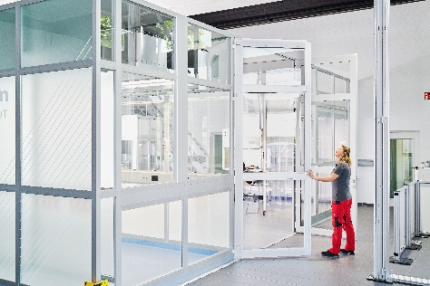
Captions
Image 1 The new double doors from item can be used to equip clean rooms or cabins with large passageways.

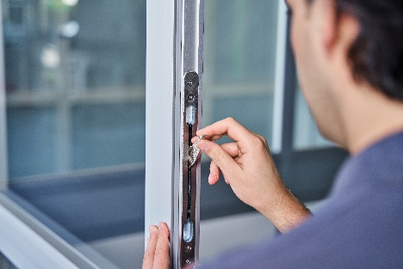
Image 2 The new internal edge bolt ensures that the fixed sash is securely locked.

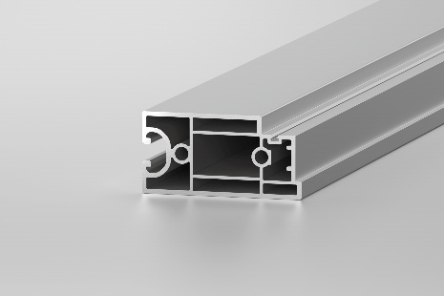
Image 3 The narrow 8 80x40 door profile forms the inside of the fixed leaf.

About item
item Industrietechnik GmbH is a pioneer in modular construction systems for industrial applications and a partner to the manufacturing industry worldwide. The product portfolio comprises more than 4,500 high-quality components for the construction of machine frames, workstations, automation solutions and lean production applications. item has received numerous awards for its products with their pioneering industrial design and consistent ergonomics.
As a pioneer in digital engineering, item is driving forward the digitalisation of design processes with software tools developed in-house. The item Academy offers training and further education through multilingual online courses and training on demand.
item is headquartered in Solingen and has subsidiaries around the world. With expertise and passion, around 900 employees worldwide develop innovative solutions and services. Customer proximity in Germany is ensured by eleven locations. A global logistics chain ensures short-term delivery of all components.

Company contact
Charlene Müller • item Industrietechnik GmbH
Friedenstraße 107–109 • 42699 Solingen
Tel.: +49 212 65 80 5133
Email: C. Mueller@item24.com • Internet: www.item24.com

Press contact
Jan Leins • additiv
A brand of additiv pr GmbH & Co. KG
B2B communication for logistics, robotics, industry and IT
Herzog-Adolf-Straße 3 • 56410 Montabaur
Tel.: (+49) 26 02-95 09 91 6 • Fax: (+49) 26 02-95 09 91 7
Email: jl@additiv.de • Website: www.additiv.de

