Planning concepts of the future
The cardboard engineering of tomorrow – swapping cardboard and wood for a VR headset

Getting the best results more quickly – that was the outcome of a workshop on using virtual reality (VR) to design an industrial work bench. The workshop is part of a new planning concept that item is rolling out. Working with Halocline, which has developed software for planning within a virtual space, the company’s digital engineering experts configured a work bench for the production of a new medical product from Sanner. This successful collaboration shows clearly just how much potential can be unlocked by incorporating the virtual world into industrial planning processes.

In lean production, cardboard engineering is the method of choice when trying to efficiently plan industrial work benches. It involves building a model of the bench out of cardboard and wood, then adapting the model to the relevant requirements. This means production sequences can be simulated and ergonomically optimised true to scale. However, cardboard engineering takes up a lot of space, with models built on a scale of 1:1 because that is the only way to conclusively evaluate actual working processes. Often, that means having to replicate large production areas. Using virtual reality to create and validate assembly work benches is a simpler, more sustainable and much less time-consuming alternative.

Virtual cardboard engineering for a real product
The Sanner Group, which is based in Bensheim, develops solutions in the fields of medical technology, diagnostics, pharmaceuticals and consumer healthcare. The company is a global market leader in desiccant packaging for the pharmaceutical industry, has a workforce of over 600 in total and supplies customers in more than 150 countries. As part of a CDMO (Contract Development and Manufacturing Organisation) project for this particular medical technology, which requires complex manual assembly for its initial series, the manufacturer wanted to design the ideal assembly work bench. The aim is for a new drug delivery system to be manufactured efficiently within an optimum working environment in the future. To achieve this aim, Sanner turned to item Industrietechnik GmbH, a pioneer in the field of building kit systems for industrial applications and a trailblazer in digital engineering. For example, the Work Bench Configurator developed by item can be used to design work benches digitally, while also adapting them perfectly to efficiency requirements, process specifications and the needs of staff. The company’s digital engineering experts also collaborate closely with Halocline GmbH & Co. KG, which has developed a software solution for VR production planning. The two companies put their heads together in a workshop and configured a new work bench for Sanner. “We wanted to explore the opportunities that would be opened up by combining our products and tools with VR,” explains Christian Thiel, Senior Product Manager at item. “We can make changes to constructions quickly and easily and then immediately switch to a virtual environment to check how these modifications might impact the working processes.” Virtual cardboard engineering is certainly much more agile than its conventional counterpart, which is based on mock-ups built using wood and cardboard.

Creating geometries quickly and easily
Halocline has created the perfect conditions for planning an assembly work bench or rack construction. “We’ve worked with Halocline to establish a kind of gallery filled with sample applications from item so users can set up a basic production environment in a virtual world in just a few clicks,” explains Thiel. Without needing any special training or prior knowledge, users can create simple geometries such as boxes in the software, select relevant components and thus very quickly design new concepts. However, they could also conceivably start by creating a basic concept with the online tools offered by item and then transfer that to Halocline. Either way, the planning concept always revolves around the working process. There are numerous key questions to consider, such as: Where does material have to be transported to? Which individual work steps need to be carried out? Where do essential tools need to be positioned to ensure the whole sequence flows smoothly and ergonomically? It is also really important to clearly specify requirements. “In VR, you focus very much on the product and the process,” points out Thiel. “The VR results can then be used to finalise the engineering project in more detail using the online tools.” Once users have run through and evaluated their processes in the virtual world, they know precisely where elements such as small load carriers (SLCs) should ideally be positioned to optimise reaching actions at the work bench. The Work Bench Configurator then gives users the opportunity to customise the handling area. Countless components such as tablets, tablet pivot arms or container profiles that hold parts containers can be added wherever required. Thanks to intuitive drag-and-drop parts placement and automatic adjustments, users can complete their assembly work bench on the tool’s 3D work area in next to no time. At the start of the project with Sanner, a joint workshop was held to create a range of bench variants. The company used the virtual cardboard engineering technique to identify the fundamental requirements, develop the concept and then carry out more detailed planning. The main focus during these stages was on the handling areas at the work bench. After all, when manufacturing the initial-series version of the dosing aid, production staff need to fit elements into a manual press by hand. Once this process had been played through in the virtual world, item adapted the bench concept during more detailed planning aimed at optimising the working environment.

Six variants were whittled down to the ideal work bench
The workshop with item, Sanner and Halocline lasted half a day. The first step was to specify the objectives. The participants then had the chance to don a VR headset and enter their virtual world. “You really need to experience VR to get to grips with sizes and dimensions,” Thiel explains. “It’s about getting a feel for the virtual world.” Six different versions of the work bench were developed during the concept planning stage. That meant making sure all the necessary objects and tools for the assembly process were available in the software. Making the various models out of cardboard and wood using conventional cardboard engineering techniques would have required a lot of materials and taken a long time. By contrast, with help from Halocline, the team was able to configure the different designs fairly easily, before copying and modifying them. The next stage was to evaluate the designs within the actual working process. This resulted in two models that were then put through another intensive series of tests in VR. A member of staff from Sanner validated the assembly process at the virtual model of the workstation. This revealed whether the tools and SLCs on the final work bench model were located in the best possible positions for the working process. A spaghetti diagram was used to visualise all the working procedures and show exactly how the workers’ hands move, how the workers themselves move and how efficient the assembly sequences are. Finally, there were just a few small details to fine-tune on the bench.

Special requirements for the work bench system
The work bench is designed for use in a cleanroom. Thanks to their smooth, unbroken surfaces, item components are ideal for this sensitive working environment. The modular systems can be rapidly and easily extended or adapted and thus offer maximum flexibility in the planning and implementation phases. Since the medical product in question needs to be protected against electrostatic discharge (ESD), an electrostatic protected area (EPA) was essential. The table top is made of special materials and safely dissipates charges to prevent damage to electrical components. All the various parts comply with the limits stipulated in IEC 61340 for both discharge and surface resistance. The bench is height-adjustable and features several pivot arms, which means the working area can be adapted to the physical proportions of the person working at it. Material supply and picking arrangements are also ergonomic. Open SLCs arranged one above the other offer staff a clear view of their contents, which can be removed via specially shaped grab trays mounted directly onto the front of the SLCs that make it easy to pick even the smallest of parts by hand. Materials and tools that aren’t currently being used can be set to one side. For example, a keyboard and monitor are located at the side, on a keyboard shelf and tablet arm, which means the working surface always offers plenty of space for actual assembly work.

All in all, using VR as part of the planning process helps to deliver a product that meets customer requirements in full. The VR headset transports the wearer to a three-dimensional, digital world where they can truly “experience” the work bench. It gives them the ideal opportunity to adapt the bench to the relevant requirements and their own physical dimensions. Work sequences are validated and the functionality and ergonomics of the work benches are checked. This ensures that any design errors or inefficient work sequences can be identified quickly. Ultimately, this approach does not just benefit product design, but the entire planning process, which is considerably speeded up and optimised. Combining VR software from Halocline with the online tools from item unlocks maximum flexibility for the future of work bench design.

Length: 10,004 characters including spaces
Date: 21 July 2022

Images: 4 (Source: item)

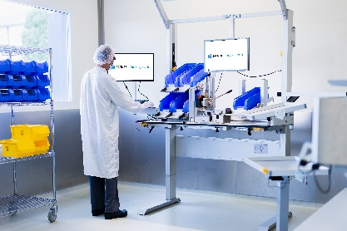
Caption 1: Virtual reality (VR) plays a big part in the new planning concept from item. item joined forces with VR software development company Halocline to configure a work bench for manufacturing a new medical product from Sanner.
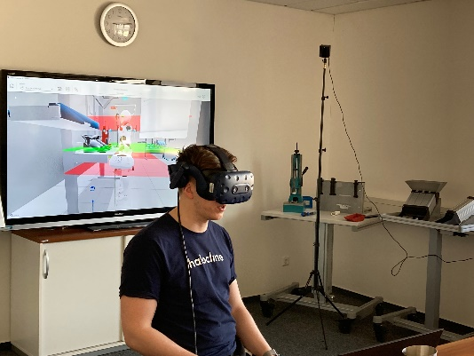
Caption 2: A virtual production environment can be created in just a few clicks.

Caption 3: During a joint workshop, virtual cardboard engineering was used to identify the fundamental requirements, develop the concept and then carry out more detailed planning. The main focus during these stages was on the handling areas at the work bench.

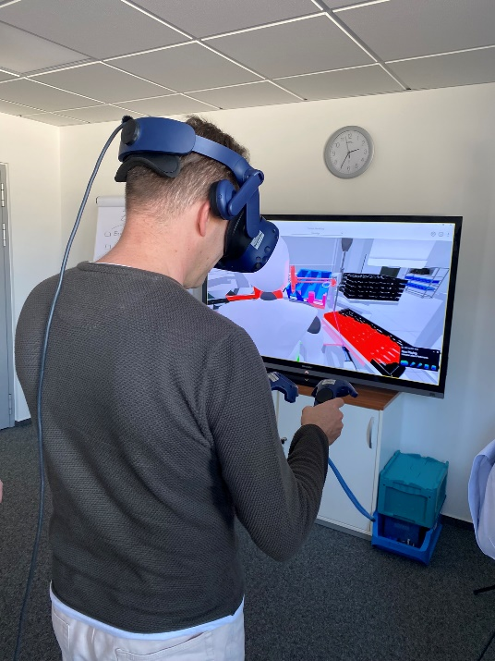

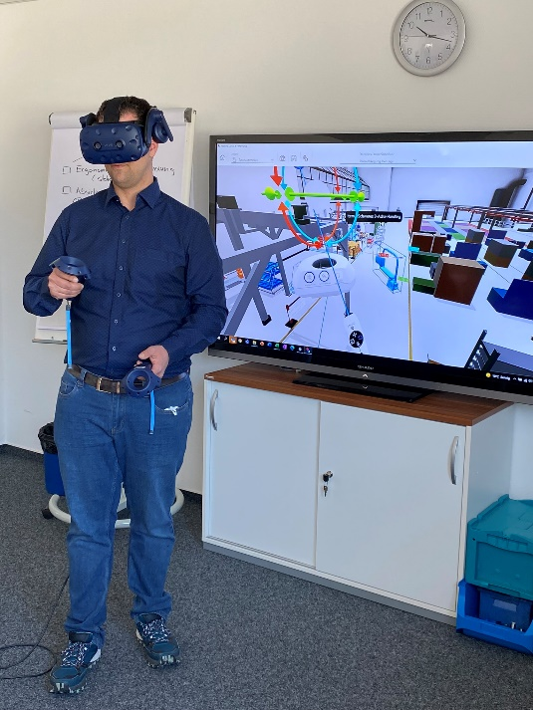
Caption 4: A member of staff from Sanner validated the assembly process at the virtual model of the workstation.

About item
item Industrietechnik GmbH is the pioneer in building kit systems for industrial applications and a partner of the manufacturing industry across the entire globe. Today, the item product portfolio comprises more than 4,000 high-quality components designed for use in machine bases, work benches, automation solutions and lean production applications. The company has received a string of awards for products with ground-breaking industrial design and end-to-end ergonomics.

item is spearheading digital engineering by driving forward the digitalisation of processes with software tools developed in-house. The item Academy offers training at various levels, with on-demand training and online courses available in multiple languages.

Headquartered in Solingen, Germany, item has subsidiaries in various countries. Some 900 employees worldwide harness their know-how and passion to develop innovative solutions and services. Twelve sites make sure the company is always close to customers in Germany, with a global logistics chain ensuring swift delivery times for all components.

Company contact
Nicole Hezinger • item Industrietechnik GmbH
Friedenstrasse 107 - 109 • 42699 Solingen • Germany
Tel.: +49 212 65 80 5188 • Fax: +49 212 65 80 310
Email: n.hezinger@item24.com • Internet: www.item24.com

Press contact
Jan Leins • additiv pr GmbH & Co. KG
Press work for logistics, steel, industrial goods and IT
Herzog-Adolf-Strasse 3 • 56410 Montabaur • Germany
Tel.: +49 26 02-95 09 91 6 • Fax: +49 26 02-95 09 91 7
Email: jl@additiv-pr.de • Internet: www.additiv-pr.de/maschinenbau

